Handling imbalanced datasets in machine learning is crucial for building models that can effectively generalize to real-world scenarios. Here are several techniques to address this issue:

1. **Collect More Data**
2. **Resampling Techniques**:
   1. **Under Sampling**
   2. **Overt Sampling**
   3. **SMOTE Over Sampling**:
3. **Ensemble Methods**:
4. **Class Weighting**:

**Collect More Data**:

If feasible, collecting more data can help balance out the classes in your dataset. However, this might not always be possible.

**Resampling Techniques**:

**Undersampling**:

Randomly remove samples from the majority class to balance the class distribution. This can lead to loss of information.

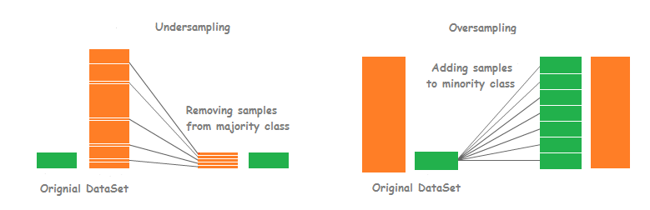

from imblearn.undersampling import RandomUnderSampler

**Oversampling**:

Increase the number of minority class samples by duplicating them or generating synthetic examples. Techniques like SMOTE (Synthetic Minority Over-sampling Technique) are commonly used for this purpose.



from imblearn.over_sampling import RandomOverSampler

**SMOTE(Synthetic Minority Over-sampling Technique)**:

Techniques like SMOTEENN (SMOTE + Edited Nearest Neighbors) combine both oversampling and undersampling to achieve a balanced dataset.

from imblearn.over_sampling import RandomOverSampler

**Ensemble Methods**:

Utilize ensemble methods like bagging and boosting with resampling techniques to create multiple models that are then combined. This can help improve generalization and mitigate the impact of class imbalance.

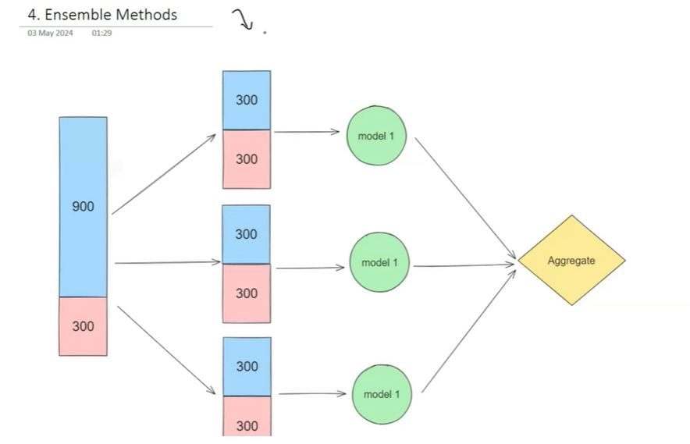

from imblearn.ensemble import BalancedRandomForestClassifier

**Class Weighting/Cost Sensitive Learning**:

In many machine learning algorithms, you can assign higher weights to minority class samples. This encourages the model to pay more attention to these samples during training. Most classifiers in scikit-learn have a **class_weight** parameter for this purpose.

model = LogisticRegression(class_weight={0: 1, 1: 10}) # Assigning weight of 10 to class 1

model = DecisionTreeClassifier(class_weight={0: 1, 1: 10}) # Assigning weight of 10 to class 1

model = RandomForestClassifier(class_weight={0: 1, 1: 10}) # Assigning weight of 10 to class 1

model = SVC(class_weight={0: 1, 1: 10})

Assigning weight of 10 to class 1

1. **Different Algorithms**: Some algorithms are naturally more robust to class imbalance than others. For example, decision trees and random forests can handle class imbalance well, while others like logistic regression may struggle.
2. **Evaluation Metrics**: Avoid using accuracy as the primary evaluation metric, especially for imbalanced datasets, as it can be misleading. Instead, use metrics like precision, recall, F1-score, ROC-AUC, or precision-recall curves that provide a better understanding of the model's performance across different classes.
3. **Cross-Validation**: Ensure that your cross-validation strategy properly handles class imbalance. Techniques like stratified k-fold cross-validation maintain the class distribution in each fold.
4. **Data Preprocessing**: Carefully preprocess your data, including feature scaling, normalization, and outlier detection, to improve model performance.
5. **Anomaly Detection**: If the imbalance is extreme and the minority class represents anomalies or rare events, consider treating the problem as an anomaly detection task rather than a classification problem.

The choice of technique depends on factors such as the nature of the data, the imbalance ratio, and the specific machine learning algorithm being used. It's often beneficial to try multiple approaches and evaluate their performance using appropriate metrics.